**EXAMEEEXAM CENTER ALLOTMENT SYSTEMALLOTMENT SYSTE**

1.1 PROJECT PURPOSE:

The purpose of this project is Exam Centre Allotment based on the candidate exam.The procedure of assigning candidates to a certain exam centre is known as exam centre allotment. Exam centres are assigned to candidates based on their candidate and exam IDs. This information is stored in text files.

1.2 FUNCTIONALITIES OF THE SYSTEM:

These functionalities have been implemented in the program:

* Candidates appear for various exams. Exams are conducted in 3 exam centres.
* Candidates apply for various exams by using credentials of candidate ID and name.
* Maintain following information for candidates:
  + Candidate ID
  + Name
  + Exam ID
  + There are three types of exams. The attributes of the exams are as follows

1. EAMCET

Math

Physics

Chemistry

1. UPSC

Start date

End date

State

1. MPSC

Start date

* + There are three exam centres. They are
  + Exam Centre 1
  + Exam Centre 2
  + Exam Centre 3
  + After assignments are done admin display total number of candidates and remaining capacity of exam center .
  + Invalid candidates entires from all input files should be written to invalid Candidates.txt.file.
  + Candidates appear for the exam based on the details mentioned in hall ticket.

1.3 OPERATING ENVIRONMENT:

* Exam centre allotment system
* Operating system: Linux
* Platform: Ubuntu

**2.FLOW DIAGRAM:**

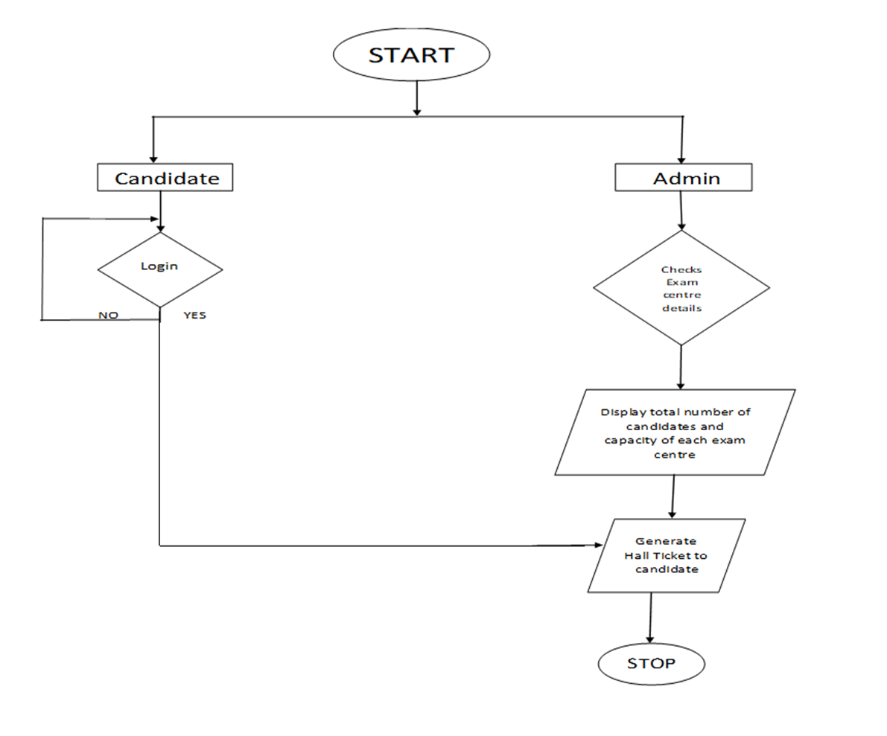

START:

This is the start block which indicates the start of the program.

1.CANDIDATE:

Candidate has to login by providing the required credentials. Candidates has to give the valid details of ID, name, exam to be appeared.

2.LOGIN:

Candidate has to login by providing the required credentials and get apply for the exam i.e, UPSC, NEET.

3.ADMIN:

Admin will generate the hall ticket and allot the exam centers according to the requirement.

4.EXAM CENTER:

After assignments are done admin display total number of candidates and remaining capacity of exam center.

5.Invalid candidates entires from all input files should be written to invalid Candidates.txt.file.

6.Candidates appear for the exam based on the allotment.

CONCLUSION:

Exam Center Allocation System can be used by the government while conducting competitive exams. Achieving this objective is difficult using a manual system as the information is scattered, can be redundant and collecting relevant and collecting relevant information may be very time consuming. By using this system, the candidates can easily appear for the exam.